**Coursework 1 Design Document**

Introduction

In this design document, we will be detailing all the research and design choices that was made to create our models and model showcase for our design challenges.

Design Challenge 1

Design Challenge 1 Specification:

In the design challenge specification, it says “You have been chosen to exhibit in the 100th anniversary of the virtual door expose! We need you to design and build a door to showcase for the event. I know it is short notice, but we need your best work. If it was possible to interact with the door and was accompanied by some sounds that really bring out the door’s personality, I think you could win!”

For this specification, I have decided to take my approach on this Challenge is by creating a door from the past.

User Story Map:

After brainstorming some potential ideas, I decided to come up with the idea of making a castle door for this challenge. First things first, I decided to expand these ideas with a user story map (shown below).

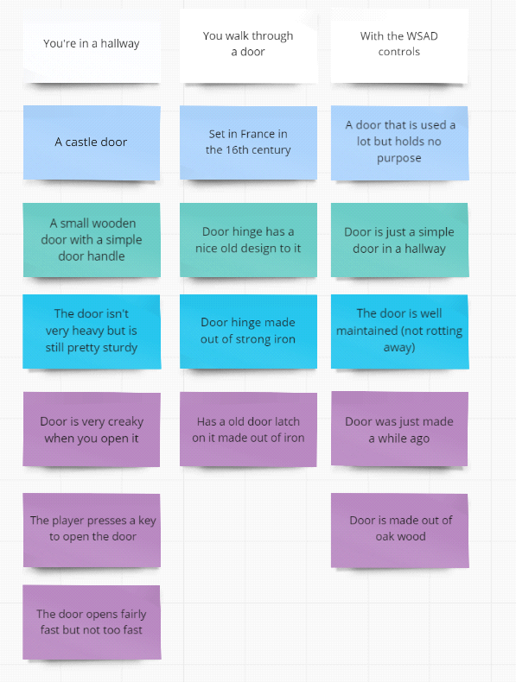

This story map helped me narrow down the specifics of what I want my door to be for my challenge.

Door Mood-board:

Next, I decided to look for some ideas for the visuals of my door. Using the expanded ideas from the User Story Map, I came up with this mood-board showcasing the visual ideas for my door.

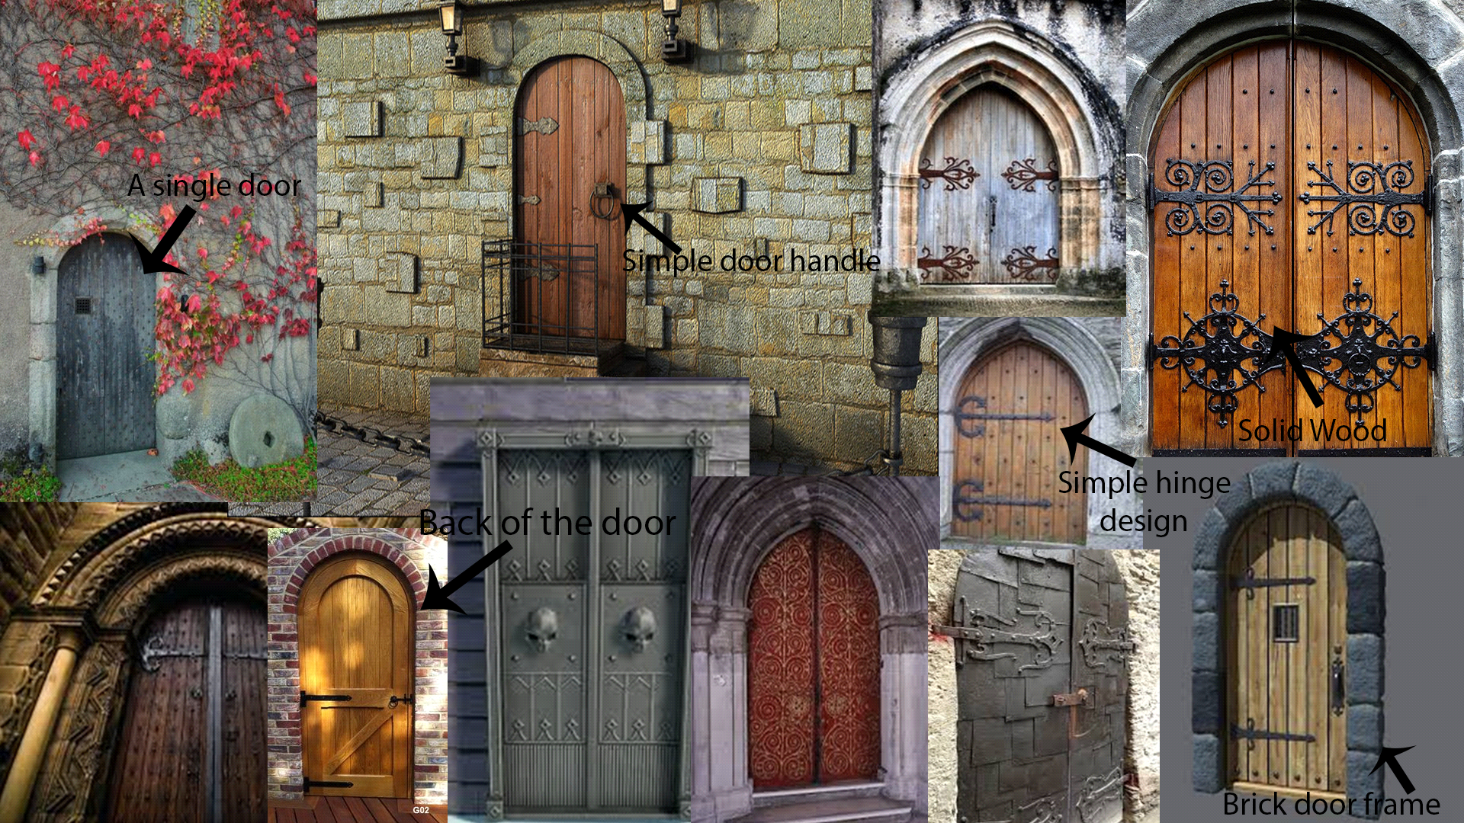

After evaluating the different types of castle doors, I finally came up with the idea to make 1 small wooden door with a simple door handle and a not too complex design for the hinge.

I also decided to draw out some sketches to see what kind of hinge design I wanted.

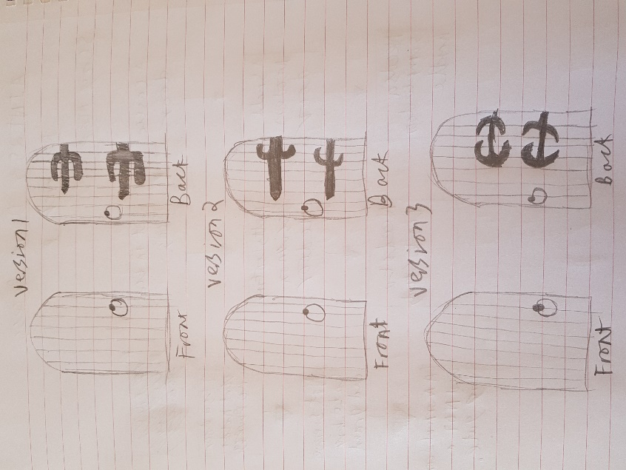

The final version of the door was using the basis of the Version 2 door but without the curves and added a bit more structure to the back of the door so that you can clearly see how sturdy the door is.

However, after some planning and changes I ended up realizing that a curved door would take more time that I don’t have so I decided to change the door from a curved door to a regular door.

Audio Mind Map:

I also decided to create an audio mind map to pinpoint what sounds and what kind of atmosphere I want for my scene.

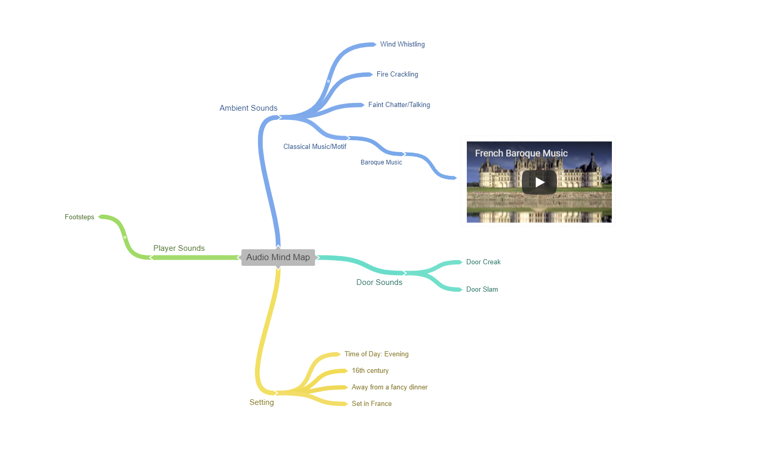

In this mind map, I fully decided on the setting and the time of the setting. I also considered what is happening during the scene as well which involves a dinner far away with classical baroque music playing as well.

Thematic Mood-board:

I also decided to create a mood-board of the themes and look of the setting that the door is based in. Using the mood-board, I decided to create a hallway with the door on the opposite end and when you open it, it’ll lead you into a dark stairway lit by torches.

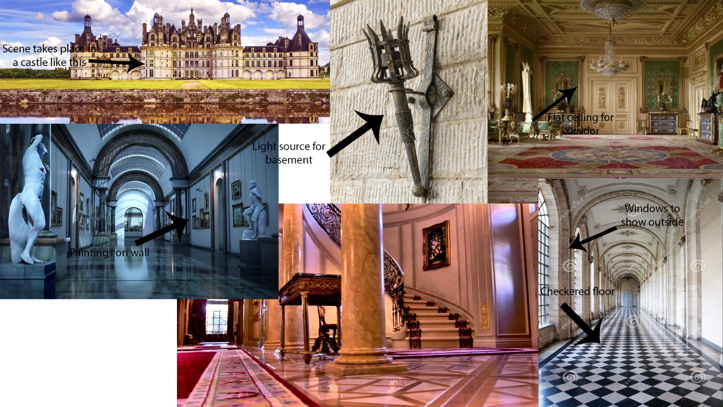

I also decided to sketch what the hallway would look like and what extra touches of detail would be included as well.

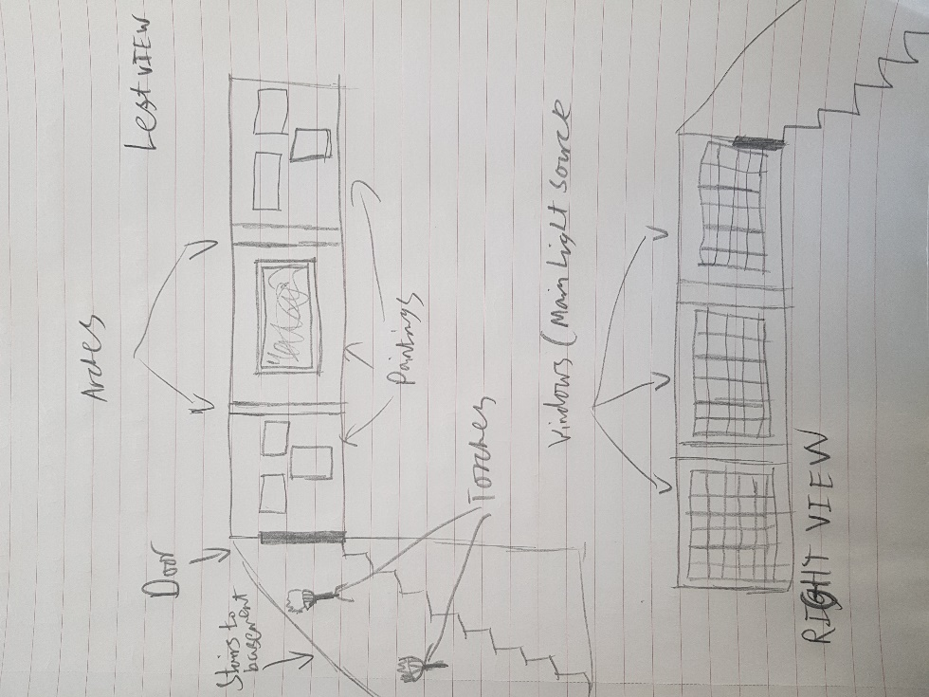

Design Challenge 2

Design Challenge 2 Specification:

For this Design Challenge, I was tasked with interviewing a fellow student about what their room looked like, so I could create a scene of their room using models that I made myself.

To start off with, I decided to expand on what the Specification wanted so I made a User Story Map about it.

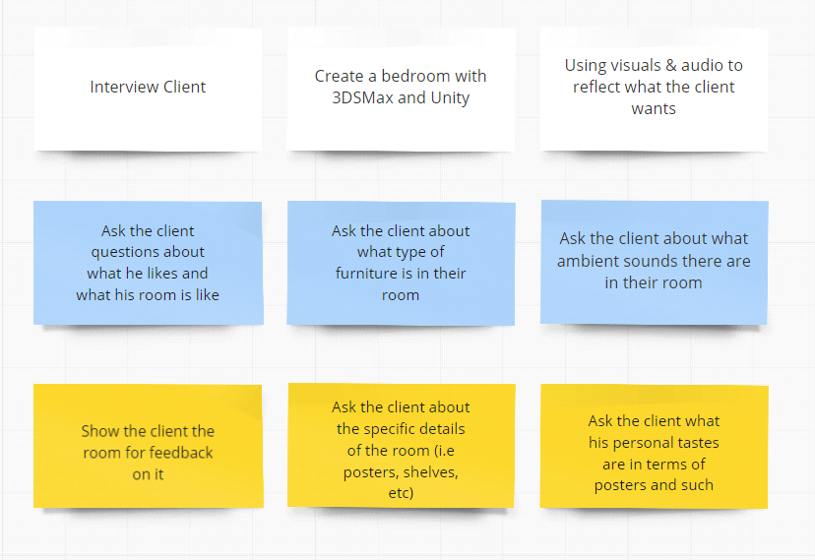

After expanding on the design spec, I decided I want the room to be based on what the interviewee's room is instead of what their dream bedroom would be.

I then made some simple and basic questions about what the interviewee's bedroom is. Down below is the questions I asked and the answers I received:

*Q: How big is your room?*

A: My room is shaped like a rectangle

*Q: How big is your bed?*

A: A Single Bed

*Q: Do you have any furniture in your room and if so, what is it?*

A: A wardrobe, a computer chair, a bed and an electric heater.

*Q: Do you have an en-suite bathroom in your room?*

A: Yes

*Q: What colour is your walls?*

A: White

*Q: Would you like to have wallpaper in your room?*

A: No

*Q: What kind of ambient noises are in your room?*

A: Noise from the laptop fan.

*Q: How big is your desk?*

A: Just a normal sized computer desk

*Q: Do you have any posters/wall art in your room?*

A: No

*Q: Do you have a Computer/Laptop/TV in your room and if so, what is it?*

A: Laptop

*Q: Do you listen to music and if so, what kind of music is it?*

A: Video Game Music and Jazz Covers of VG music

*Q: Do you have a window and if so, how big is it and what can you see outside of it?*

A: I have a window that’s a bit big and looks out over the university.

*Q: Is the floor made from carpet or floorboards?*

A: Floorboards.

User Story Map:

After interviewing my client, I decided to create another User Story Map to show off what I need to do for my bedroom.

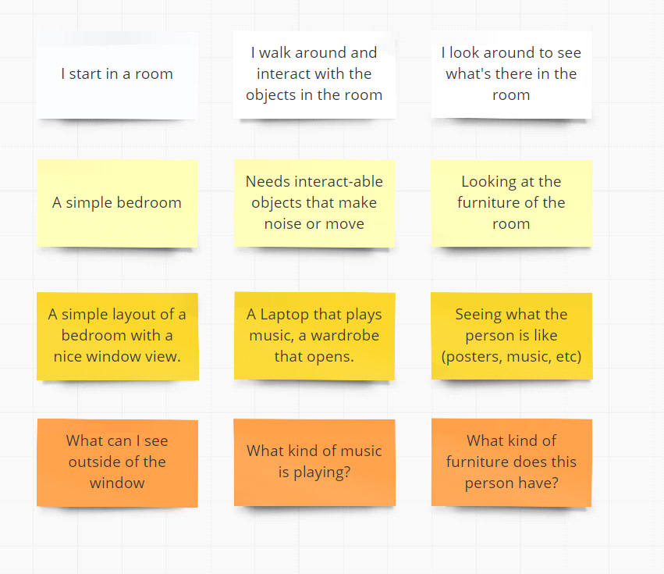

This story map made to think more in detail of what the room needs to be, in order to feel very realistic and grounded in reality.

Visual Mood-board:

After creating the User story map and interviewing my client, I began to work on a visual mood-board to help me create the models.

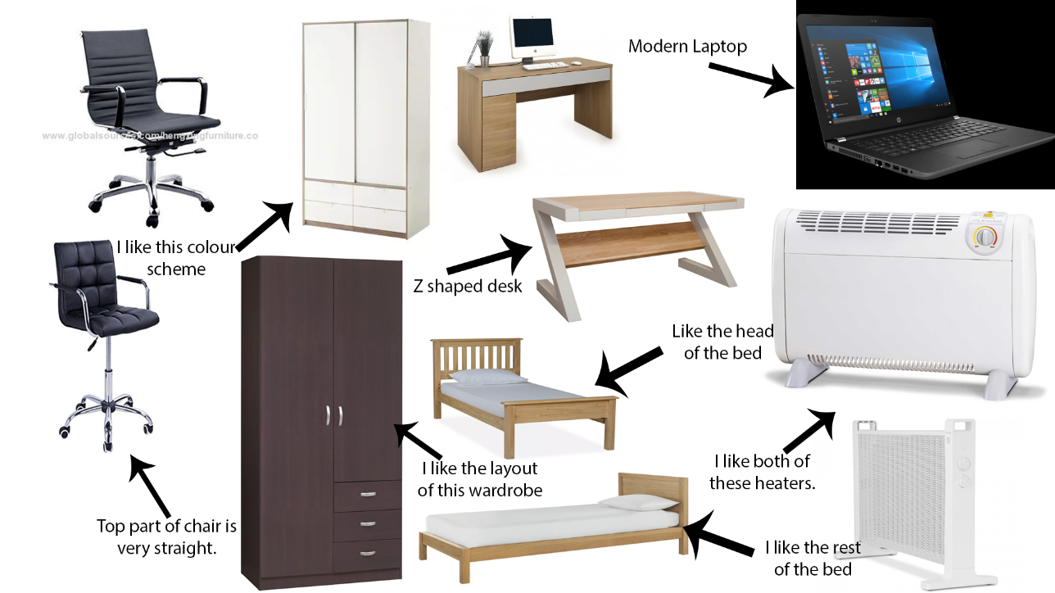

As you can see above, I decided to take inspirations from the Z shaped desk, the modern laptop, the wardrobes, chairs and beds. As the client didn’t say anything about posters, I decided to leave that out.

After making some decisions in terms with how I wanted the furniture to look like, I drew concept art of the things I wanted. 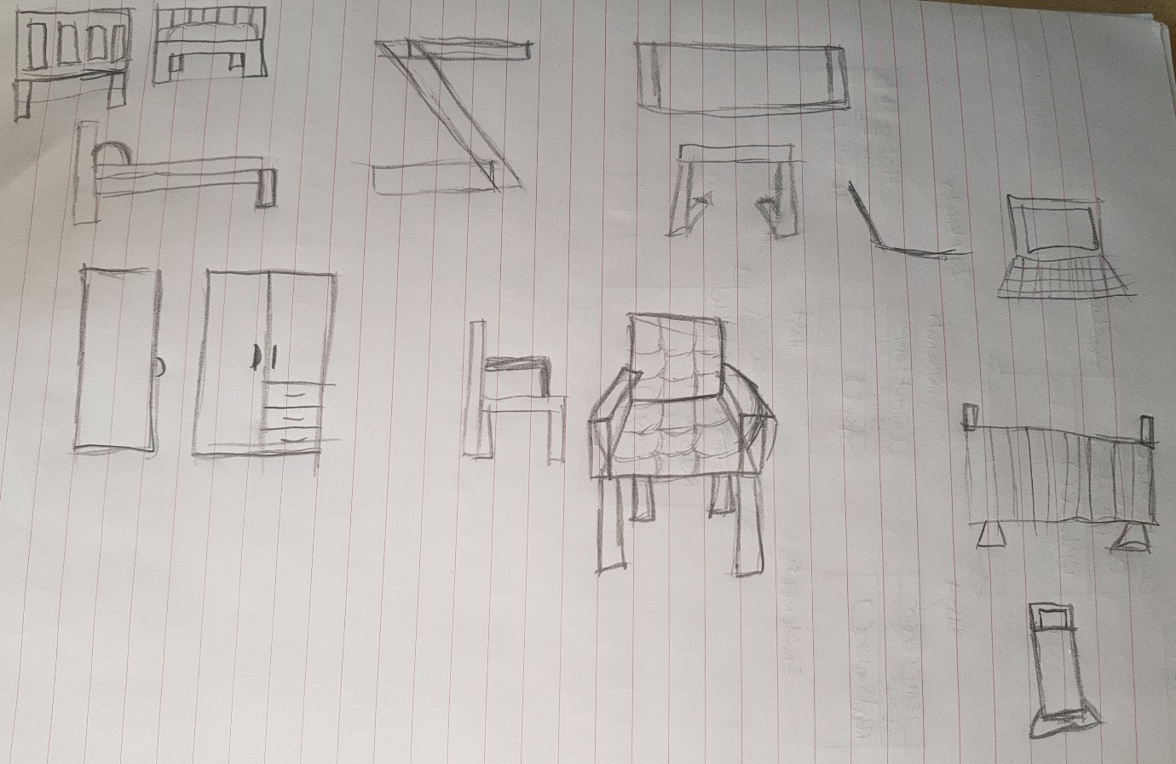

This gave me a clearer design of what I wanted in my design choices. I also decided to do a top down view of the bedroom to give a clearer view of what I needed to do for the client.

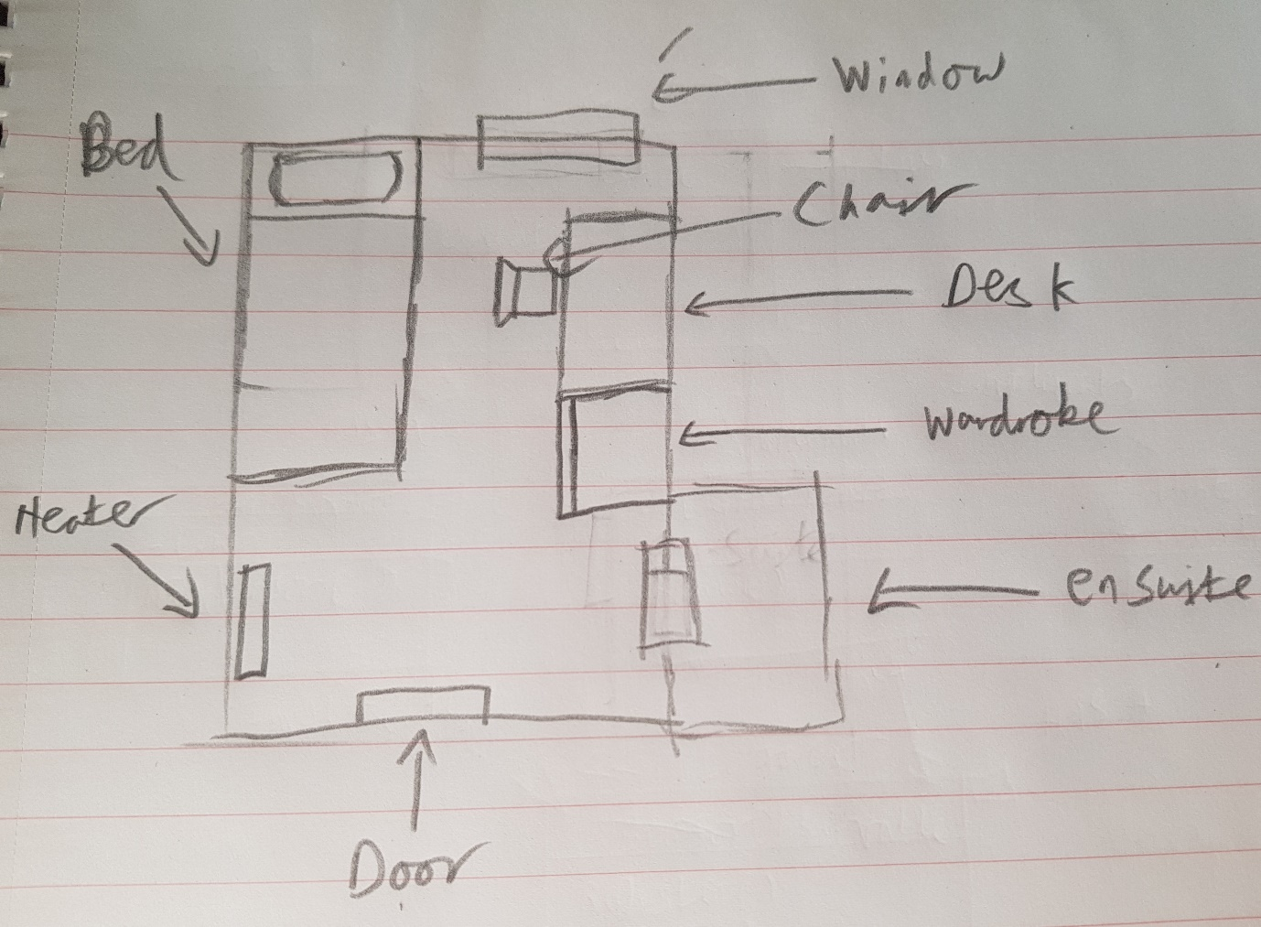

This helped me out a lot more in terms of where to put everything and what kind of space I have to work with in Unity.

References Design Challenge 1

Door Mood-board:

<https://static.artfire.com/uploads/mfs/items/97/7e/large/977e7ba0eac4b7403d7b87d48a41b2af516b50b2aa76a750d5bd6e295f90085d.jpg>

<https://i.pinimg.com/originals/fc/91/a4/fc91a4a46083566e26f97b55bb7eaf27.jpg>

<https://i.pinimg.com/236x/9d/de/29/9dde29d0e2c38778ab37096862338706--castle-doors-blue-doors.jpg>

<https://preview.free3d.com/img-dev/2017/04/1761058959432615692/jmhvtv1f-900.jpg>

<https://i.pinimg.com/236x/b6/b8/81/b6b88135026bf5d5b194aa6a3e25eec9--kids-clubhouse-castle-doors.jpg>

<http://everywear.me/wp-content/uploads/2018/01/castle-door-castle-doors-by-castle-doors-and-windows.jpg>

<https://vignette.wikia.nocookie.net/planet-coaster/images/2/23/Planet_Coaster_-_Gothic_Castle_Door.png/revision/latest?cb=20171014191906>

<https://www.britainexpress.com/images/attractions/editor/Crathes-Castle-8538.jpg>

<https://www.stgeorges-windsor.org/wp-content/uploads/2017/08/Gilebertus450.jpg>

<https://storage.needpix.com/rsynced_images/castle-475413_1280.jpg>

<http://www.jonathanelwellinteriors.co.uk/oakdoors/archeddoorback.jpg>

Thematic Mood-board:

<https://res.cloudinary.com/prestige-property-group/image/upload/q_auto,f_auto/resources/nw/images/hero/fr-chateau3.jpg>

<https://thumbs.dreamstime.com/z/castle-corridor-27352423.jpg>

<https://previews.123rf.com/images/alikaj/alikaj1801/alikaj180100056/93017801-removable-iron-torch-on-a-medieval-castle-stone-wall.jpg>

<https://pre00.deviantart.net/46d1/th/pre/f/2010/018/0/9/french_museum_hallway_at_night_by_karimrehimi.jpg>

<https://i.pinimg.com/originals/43/5b/3a/435b3a70241a7648a364b7c312d7e51b.jpg>

<https://i.ytimg.com/vi/VEkdjyRdZdo/maxresdefault.jpg>

References Design Challenge 2

Visual Mood-board:

<https://product-images.www8-hp.com/digmedialib/prodimg/lowres/c05517848.png>

<https://p.globalsources.com/IMAGES/PDT/B1113379689/Office-Leather-Executive-Computer-Chair-Metal-Base-Nylon-Castors.jpg>

<https://www2.le.ac.uk/offices/estates/environment/images/electric-heater/image_view_fullscreen>

<https://cdn6.elektronik-star.de/out/pictures/generated/product/1/700_700_75/10032062_uk_0001_front___Klarstein_HeatPalMica20_Elektrische_Heizung_weiss.jpg>

<https://cdn.aosom.co.uk/media/catalog/product/cache/1/image/9df78eab33525d08d6e5fb8d27136e95/0/2/02-0697_2.jpg>

<https://cdn.jysk.ca/media/catalog/product/cache/1/image/9df78eab33525d08d6e5fb8d27136e95/r/a/rauma_2.jpg>

<https://www.ikea.com/gb/en/images/products/trysil-wardrobe-w-sliding-doors-4-drawers-white__0452604_pe601521_s4.jpg>

<https://www.directofficesupply.co.uk/components/com_virtuemart/shop_image/product/resized/3d266f6df06e04c45b66ef5e0cd0bd7d.jpg>

<https://cdn.habitat.co.uk/media/catalog/product/cache/1/image/1200x/9df78eab33525d08d6e5fb8d27136e95/3/3/339886.jpg>